# Current Character Avatar Designs:

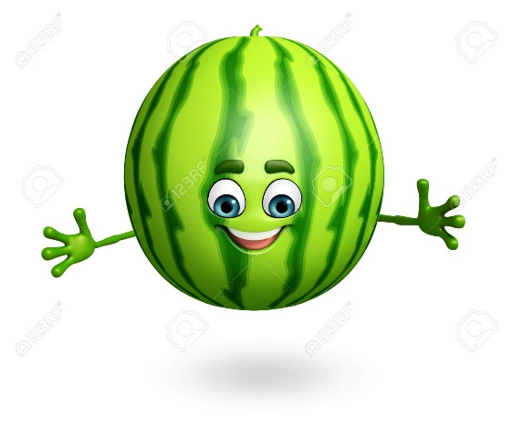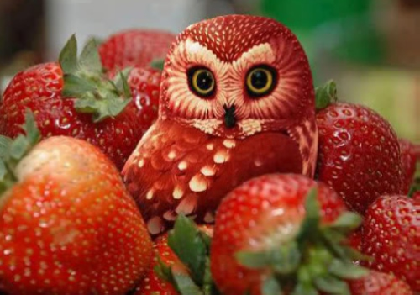

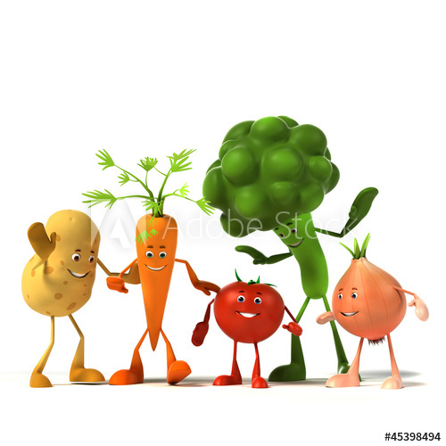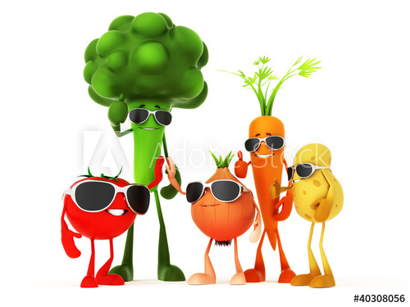**[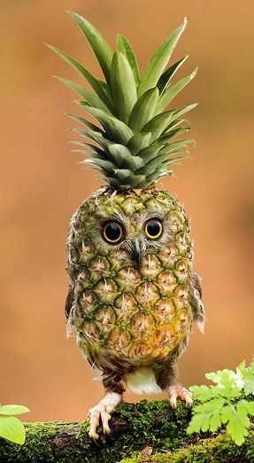](http://imgur.com/r/Owls/4jintJC)**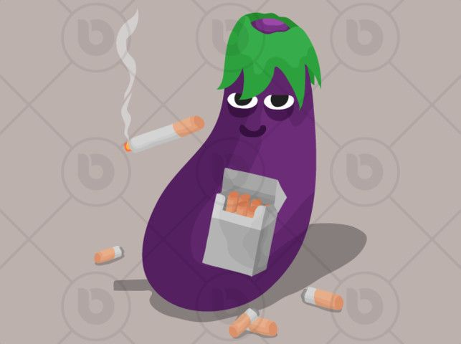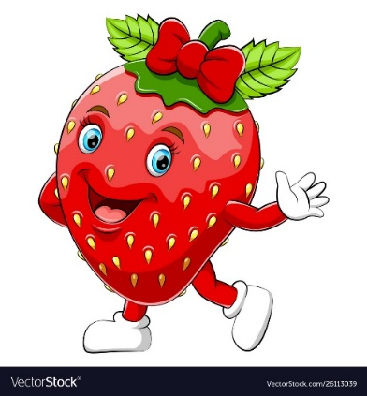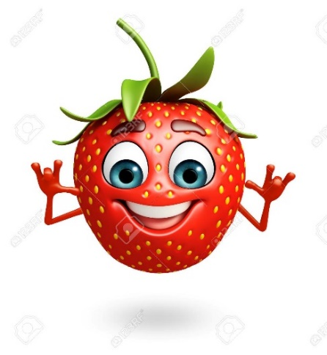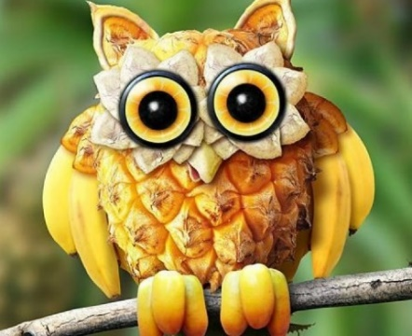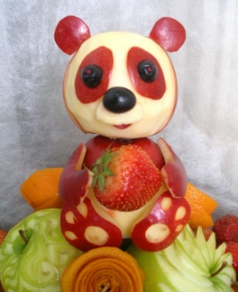

**[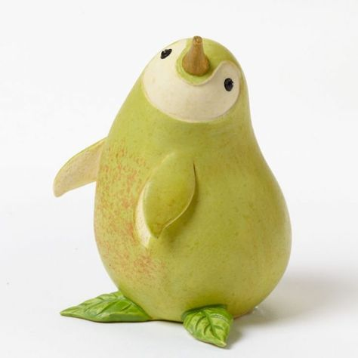](https://food.howtocrafts.online/pear-penquin-%E2%80%A2-fairly-certain-this-is-ceramic-but.html)[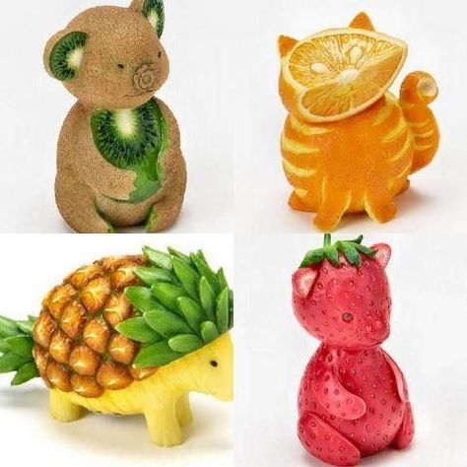](http://pinterestinglady.com/fruit-animals/)[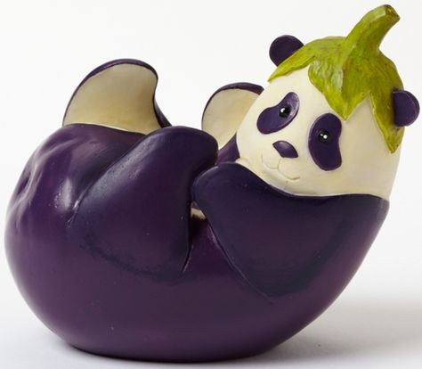](http://www.collectorsaddition.com/gentu/HG4043779.htm)[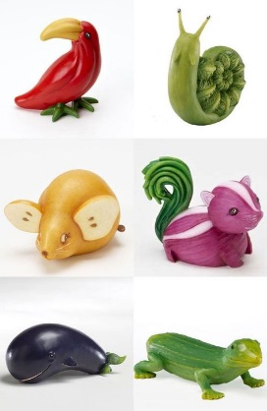](https://bitte.benefitoftea.net/love-this-wish-i-could-learn-to-make-animals-out-of-fruits-and-vegetables-sure/)**[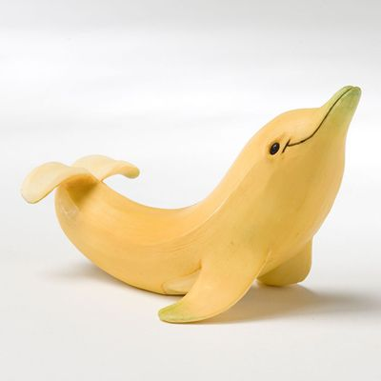](https://www.google.co.uk/url?sa=i&url=https%3A%2F%2Fwww.pinterest.com%2Fpin%2F495677502718441390%2F&psig=AOvVaw1mjWNhre44HXpeefPL5m_g&ust=1573037768728000&source=images&cd=vfe&ved=0CAIQjRxqFwoTCKDRqr300uUCFQAAAAAdAAAAABAE)

## References:

1. <https://www.pinterest.co.uk/pin/162692605258889998/>
2. <https://plugon.us/hungermania/apple-teddy-e2afe>
3. <http://www.aljanh.net/bread-and-vegetables-wallpapers/2409469284.html>
4. <https://www.123rf.com/photo_43746764_stock-illustration-3d-rendered-illustration-of-strawberry-cartoon-character.html>
5. <https://www.123rf.com/photo_43747108_stock-illustration-3d-rendered-illustration-of-watermelon-cartoon-character.html?fromid=UkNKZ1dIMlpJZG4zeFRJeWNwWjhBUT09>
6. <https://www.pinterest.co.uk/pin/586030970236877766/>
7. <https://stock.adobe.com/hu/images/3d-rendered-illustration-of-a-group-of-vegetable-characters/45398494>
8. <https://www.pinterest.co.uk/pin/29695678769799553>
9. <https://www.pinterest.co.uk/pin/495677502718441390/>
10. <https://www.pinterest.co.uk/pin/311803974203356309/>
11. <https://www.pinterest.co.uk/pin/523684262921280804/>
12. <https://www.pinterest.co.uk/pin/832040099880350738/>
13. <https://www.pinterest.co.uk/pin/354447433145211238/>
14. <https://stock.adobe.com/hu/search?serie_id=45398494&asset_id=40308056>